Fisher Esterification: Synthesis of Isoamyl Acetate

**Reference:** Handout; Chemistry lessons: carbonyl chemistry, esterification reactions, Le Chatelier’s principle; Bruice pg. 709-710

**Purpose:** To perform a Fischer Esterification reaction in creating isopentyl acetate

**Table of Reagents:**

|  |  |  |  |  |  |
| --- | --- | --- | --- | --- | --- |
| **Compounds** | **MW** | **Amount** | **BP (°C)** | **MP (°C)** | **Density** |
| Isoamyl Alcohol | 88.148 g/mol | 5.0 mL | 131 °C | -117.2 °C | 0.810 g/cm3 |
| Acetic Acid | 60.052 g/mol | 7.0 mL | 118.1 °C | 16.6 °C | 1.05 g/cm3 |
| Sulfuric Acid | 98.079 g/mol | 1.0 mL | 337 °C | 10 °C | 1.84 g/cm3 |
| NaHCO3 | 84.007 g/mol | 5.0 mL | 851 °C | 50 °C | 2.2 g/cm3 |
| Brine | 58.44 g/mol | 5.0 mL | 100 °C | - °C | - g/cm3 |

**Balanced Chemical Equation:**

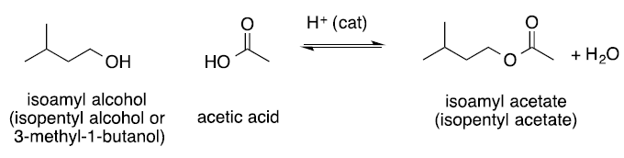

**Mechanism:**

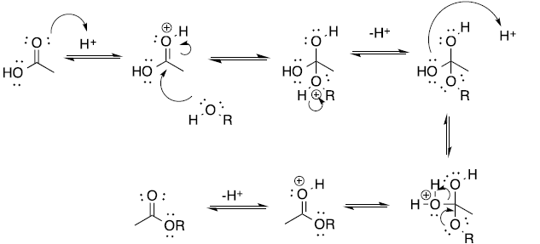

**Safety:**

* Sulfuric Acid & Acetic Acid 🡪 very corrosive; Flush with water if gets on skin

|  |  |
| --- | --- |
| **Experimental Procedures** | **Data & Observations** |
| **1.** Obtain 5 mL isoamyl alcohol, 7 mL acetic acid, & 1 mL sulfuric acid into 25 mL round bottom flask   * Equip with reflux condenser and calcium chloride drying tube |  |
| **2.** Swirl to mix and add boiling stones; Heat to reflux for 60 min then cool to RT | *Observations:* Mixture started to turn dark brown |
| **3.** Transfer to separatory funnel and extract with 10 mL water, 5 mL NaHCO3, and 5 mL Brine |  |
| **4.** Transfer product to 25 mL Erlenmeyer Flask; add 1 g Sodium Sulfate; Let sit for ~10 min |  |
| **5.** Purify with simple distillation; use ice-cooled vessel to collect | *Pure Product Melting Point:* |
| **6.** Record mass of isolated product   * Calculate % yield * Get IR/NMR | *True Melting Point:* 145 °C – 150 °C  *Product Melting Point:* 137 °C  *Product Mass:* 0.58 g |

**Post-lab Questions:**

**1. a)** Our final product was a clear liquid. The true boiling point range of the isoamyl acetate is between 145 – 150 °C, however, the melting point of the product is -78.5 °C, which explains the fact that it is a liquid in room temperature.

We collected 4.202 g of the product as well as the color of our product was clear

$$\% Yield= \frac{Product Obtained}{Theoretical Yield}×100$$

*Obtained:* 4.202 g *Color and State:* Liquid, Clear

* First, we must obtain the theoretical value of our crude product in grams:
$$5.0 mL Isoamyl Alcohol×\frac{0.810 g}{1 mL}×\frac{1 mol }{88.148 g }×\frac{1 mol }{1 mol }×\frac{130.19 g }{1 mol }=5.98 g Isoamyl Acetate$$

* Next, we must use the equation above to get our % Yield:
$$\% Yield=\frac{4.202 g}{5.98 g}×100=70.27\% yield$$

* *We received a 70.27% yield for our product*
* *We received a rather moderately high yield and the reaction was succesful*

**2. a) IR Spectrum of Isoamyl Acetate**

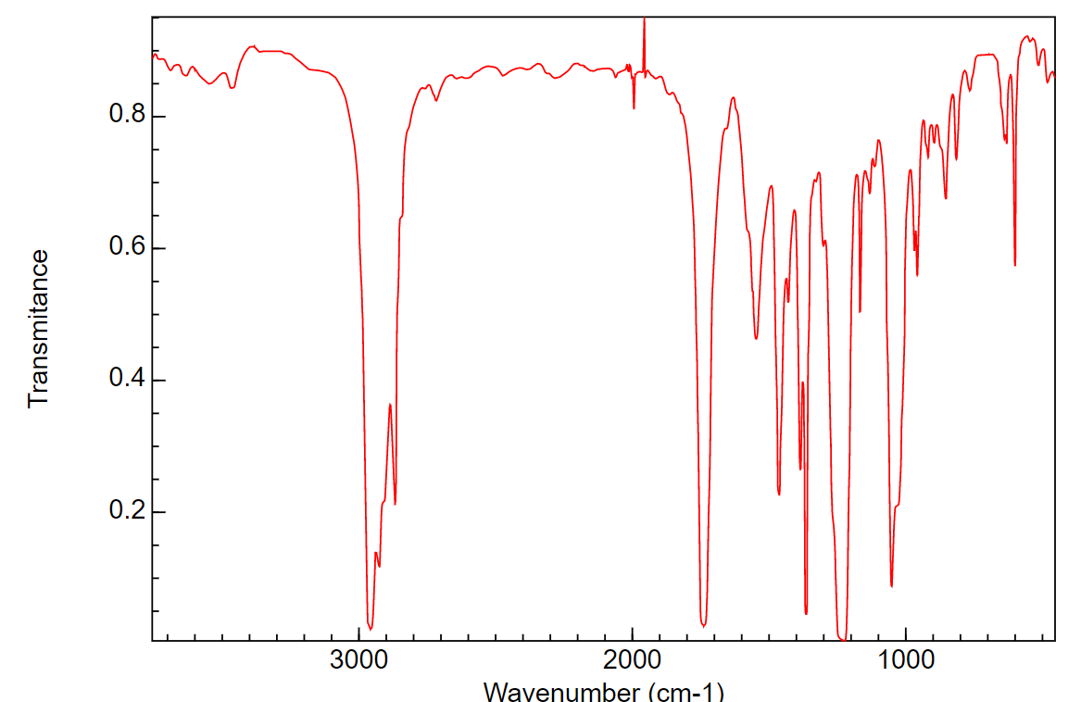



**b) NMR of Isoamyl Acetate**

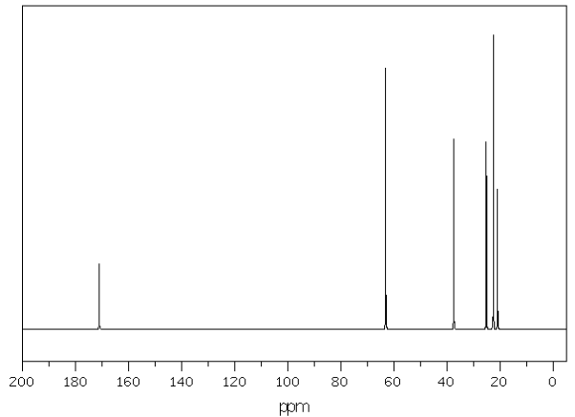



**3.** The reaction could be driven forward by removing the excess water or by adding more of the acetic acid due to Le Chatlier’s principle in that a system would want to always be at equilibrium and if disturbed would want to shift away from the constraint.

**4.**  a) The role of the sulfuric acid in the reaction was to act as the proton source (H+) to the carboxylic acid (essentially sulfuric acid was a the source of the H+)

b) The mixture was extracted with sodium bicarbonate because it was used to get rid of the excess acid in the mixture. CO2 is observed to be the gas bubbling from the mixture as the reaction takes place.

*Chemical Equation:* NaHCO3 + H2SO4 → Na2SO4 + H2O + CO2 (g)

c) Brine is essentially salt water as it is a combination of NaCl and H2O. It is used to dry the solution to help drive the reaction towards the products.

**5.**  Esters

